Stakeholder Analysis Report: Hezop PID Reader

Executive Summary
Hezop PID Reader is an AI-powered engineering intelligence tool designed to digitize and structure data from Piping and Instrumentation Diagrams (P&IDs). This report provides a detailed stakeholder analysis to guide strategic communication, manage expectations, secure buy-in, and ensure successful product development and market adoption. The analysis identifies key stakeholder groups, assesses their influence and interest, and provides actionable recommendations for engagement. Effective stakeholder management is critical, as the product’s success hinges on disrupting entrenched manual processes within complex industrial organizations.
1.0 Introduction and Methodology
The transition from static engineering drawings to intelligent, searchable plant data represents a significant paradigm shift. The Hezop PID Reader sits at the intersection of engineering, digital transformation, and operational technology (OT). Its implementation affects diverse roles within client organizations and the broader industrial ecosystem.
This analysis employs a mixed-methodology approach:
- Identification: Cataloging all internal and external entities impacted by or with influence over the project.
- Categorization & Prioritization: Mapping stakeholders based on attributes such as influence/power, interest/involvement, and attitude.
- Strategy Development: Formulating tailored communication and management strategies for each key group.
The primary tools used are the Influence-Interest Matrix and the Support-Impact Matrix.
2.0 Stakeholder Identification and Categorization
Stakeholders are segmented into Internal (within the developing organization) and External (in the market and user ecosystem).
Table 1: Internal Stakeholders
Stakeholder Group | Primary Interests & Concerns
Executive Leadership / Investors | Return on Investment (ROI), market share growth, strategic positioning, funding allocation, exit strategy.
Product Management & Development | Product-market fit, feature prioritization, development timelines, technical feasibility, user feedback integration.
Sales & Marketing Teams | Clear value proposition, competitive differentiation, lead generation, sales enablement materials, customer success stories.
Customer Success & Support | Implementation complexity, user training needs, quality of documentation, post-sales support burden.
Table 2: External Stakeholders
Stakeholder Group | Primary Interests & Concerns
Primary Users: Plant Engineers & Designers | Accuracy of data extraction, time savings, ease of use, integration with existing tools (CAD, CMMS), reliability.
Economic Buyers: Plant Management & Digitalization Leads | Total Cost of Ownership (TCO), ROI (reduced engineering hours, fewer errors), project implementation risk, scalability.
Technical Buyers: IT/OT & Systems Integration Teams | Data security (especially cloud vs. on-prem), API robustness, integration capabilities, IT infrastructure impact, data format standards (JSON).
Influencers: Senior Engineers & Subject Matter Experts (SMEs) | Preservation of engineering integrity, validation of AI outputs, handling of legacy/non-standard drawings, trust in the tool's "engineering-aware" logic.
Strategic Partners: EPC Firms & System Integrators | Opportunities for new service lines, project efficiency gains, competitive advantage in bids, co-marketing.
End Beneficiaries: HAZOP/Safety/Compliance Engineers | Improved accuracy of safety documentation, easier audit trails, enhanced process understanding for risk studies.
Competitors | Market response, feature matching, pricing strategies.
Industry Regulators & Standards Bodies | Implicit interest in tools that improve documentation accuracy and auditability, though not direct purchasers.
3.0 Stakeholder Analysis Matrices
Matrix 1: Influence vs. Interest Analysis
This matrix helps prioritize stakeholder engagement efforts by mapping their power to affect the project against their level of concern in its outcomes.
High Influence, High Interest (Manage Closely)
- Executive Leadership: Key decision-makers for resource allocation and strategic direction. Require frequent, high-level updates on business metrics (sales, growth, key accounts).
- Economic Buyers (Plant Management): Ultimately approve purchase. Engagement must focus on clear, quantifiable ROI and risk mitigation.
- Primary Users (Plant Engineers): Their adoption and advocacy are critical for success. They provide essential product feedback and can become champions or blockers.
High Influence, Low Interest (Keep Satisfied)
- Technical Buyers (IT/OT Teams): Can veto a purchase on security or integration grounds. Need to be engaged early with technical assurances, security whitepapers, and architecture reviews without overwhelming them with daily updates.
- Investors: Provide capital and strategic guidance but are not involved in day-to-day operations. Keep informed with quarterly business reviews and major milestone achievements.
Low Influence, High Interest (Keep Informed)
- End Beneficiaries (HAZOP Engineers): Will greatly benefit from the product and can provide valuable use-case insights. Regular updates through user groups, newsletters, and feature announcements are appropriate.
- Sales & Marketing Teams: Highly interested in success for their own goals. Provide them with constant updates on product features, roadmaps, and competitive intelligence.
Low Influence, Low Interest (Monitor)
- Industry Regulators: Minimal direct engagement needed. However, marketing can highlight how the product supports compliance and auditability, indirectly addressing this group.

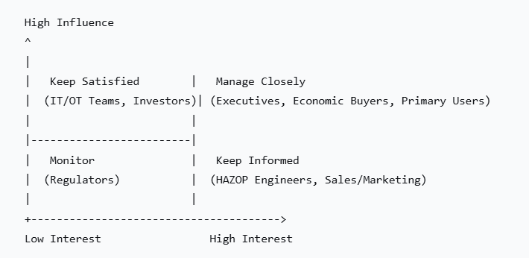
*Figure 1: Influence-Interest Matrix for Hezop PID Reader Stakeholders*
Matrix 2: Support vs. Impact Analysis
This matrix assesses stakeholder attitudes and the project's effect on them, guiding change management and communication tone.
High Support, High Impact (Champions & Key Beneficiaries)
- Primary Users (if satisfied): They experience the highest positive impact (massive time savings). If convinced, they become powerful internal champions. Nurture this relationship with excellent support and by acting on their feedback.
- Strategic Partners (EPC Firms): The product can significantly improve their project delivery. They are likely strong supporters if properly engaged. Co-develop case studies and referral programs.
High Support, Low Impact (Allies)
- Sales & Marketing Teams: The product provides them with a new solution to sell. They are supportive allies. Equip them with success stories and robust sales tools.
Low Support, High Impact (Potential Blockers / Change Resisters)
- Influencers (Senior Engineers/SMEs): The tool may be perceived as threatening their expert knowledge or may be met with skepticism about AI's accuracy. They are high-impact potential blockers. Engagement must focus on collaboration, positioning the tool as an "assistant" that augments (not replaces) their expertise, and involving them in validation processes.
- Technical Buyers (if concerns unaddressed): Can become blockers if security/integration concerns are not met.
Low Support, Low Impact (Minimal Engagement)
- Competitors: Actively opposed but limited direct impact. Monitor their activities for strategic positioning.
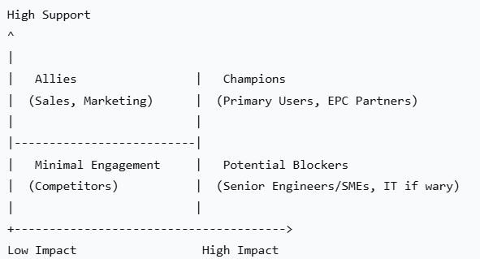
*Figure 2: Support-Impact Matrix for Hezop PID Reader Stakeholders*
4.0 Detailed Engagement Strategies & Communication Plan
Table 3: Engagement Strategy for High-Priority Stakeholders
Stakeholder Group | Key Messages | Communication Channels | Engagement Frequency
Economic Buyers (Plant Mgmt.) | ROI focus: "Reduce engineering review time by 70% and eliminate manual data entry errors." Risk reduction: "Ensure your digital twin is built on accurate, up-to-date plant data." | Executive briefings, whitepapers, ROI calculators, pilot project reviews. | Quarterly business reviews; milestone updates during pilots.
Primary Users (Plant Engineers) | Empowerment: "Get hours of your day back from tedious drawing review." Accuracy & Trust: "Our AI is trained on engineering logic—you are always in the validation loop." | Hands-on demos, webinars, user community forum, detailed documentation, in-app guidance. | Regular (bi-weekly/monthly) product updates; active community management.
Influencers (Senior Engineers) | Respect & Collaboration: "Leverage your expertise to train and validate our system." Augmentation: "Use Hezop to handle the routine, so you can focus on complex analysis." | Advisory boards, beta testing programs, co-authoring technical papers, in-depth technical deep-dive sessions. | Early and often during development; involve in validation phases.
Technical Buyers (IT/OT) | Security & Control: "On-premise or private cloud deployment options available." Integration: "Clean JSON APIs for seamless integration with your CMMS, ERP, or asset management system." | Security audits, architecture diagrams, API documentation, proof-of-concept integrations. | Early in the sales cycle; as needed during implementation.
5.0 Risk Assessment and Mitigation
Table 4: Key Stakeholder-Related Risks and Mitigations
Risk | Description | Affected Stakeholders | Mitigation Strategy
Resistance to Change | Engineers may distrust AI output and cling to manual methods. | Primary Users, Influencers (Senior Engineers) | Change Management: Position as an assistant. Implement a "human-in-the-loop" validation step. Secure an early champion from their ranks.
Integration Failures | Inability to connect Hezop's output to critical plant systems (CMMS, Digital Twin). | Technical Buyers, Economic Buyers | Technical Strategy: Develop and publish robust, well-documented APIs. Offer pre-built connectors for major platforms. Provide professional services for complex integrations.
Data Accuracy Concerns | Errors in tag or equipment extraction could lead to costly downstream mistakes. | All External Stakeholders | Product Strategy: Invest heavily in validation features (highlighting low-confidence reads). Be transparent about accuracy metrics. Start with well-defined, common drawing standards before tackling highly legacy systems.
Value Misalignment | Sales messaging focused on "AI magic" fails to resonate with engineers' practical needs. | Primary Users, Economic Buyers | Messaging Alignment: Ensure marketing/sales materials are co-developed with input from product and actual engineer interviews. Focus on specific, painful use cases.
6.0 Conclusion and Recommended Actions
The stakeholder landscape for Hezop PID Reader is complex, involving a chain of users, buyers, and influencers within client organizations. Success requires moving beyond a simple vendor-buyer relationship to becoming a partner in digital transformation.
Critical Success Factors:
- Secure the User: The plant engineer is the most critical gatekeeper. The product must earn their trust through demonstrable accuracy and time savings.
- Engage the Influencer: Senior engineers and SMEs can make or break internal adoption. Engage them as collaborators, not targets.
- Satisfy the Gatekeeper: Proactively address the security and integration concerns of IT/OT departments to remove technical procurement barriers.
- Empower the Champion: Arm economic buyers (management) with clear, compelling ROI stories derived from the successes of primary users.
Immediate Next Steps:
- Form a customer advisory board comprising representatives from Primary Users and Influencer groups.
- Develop a comprehensive pilot project framework that includes success metrics for all key stakeholder groups (e.g., time saved for engineers, data quality metrics for IT, ROI for management).
- Create differentiated communication packages tailored for each stakeholder segment identified in this report.
By systematically managing these stakeholders according to their unique interests, influence, and concerns, Hezop can significantly increase its likelihood of successful market entry and widespread adoption.

For: Hezop Product Strategy Team

